PROJECT REPORT OF INDUSTRY ORIENTED HANDS ON EXPERIENCE (IOHE)
ON

SubziKart : Hyperlocal Grocery Shopping and Delivery App
Name: Chandrakant Kumar/Lead


All MEMBERS DETAILS
NAME | ROLL NO | ADDRESS WITH EMAIL AND MOBILE NO.
Chandrakant Kumar | 2211981133 | Chitkara University,Patiala National Highway, Distt.Patiala,Punjab,India -140401  chandrakant1133.be22@chitkarauniversity.edu.in  Mob-6204168339
Himangshu Choudhury | 2211981170 | Chitkara University,Patiala National Highway, Distt.Patiala,Punjab,India -140401  himangshu1170.be22@chitkarauniversity.edu.in  Mob-8822306989
Gaurav Kumar | 2211981155 | Chitkara University,Patiala National Highway, Distt.Patiala,Punjab,India -140401  gaurav1155.be22@chitkarauniversity.edu.in  Mob-6207364264
Gurveer Singh | 2210991602 | Chitkara University,Patiala National Highway, Distt.Patiala,Punjab,India -140401  gurveer1602.be22@chitkara.edu.in  Mob-8713937575
Ajay Kumar | Supervised  By | Chitkara University,Patiala National Highway, Distt.Patiala,Punjab,India -140401  akumar@chitkara.edu.in  Mob-9467116866
DEPARTMENT OF COMPUTER SCIENCE AND ENGINEERING

CHITKARA UNIVERSITY INSTITUTE OF ENGINEERING AND TECHNOLOGY
CHITKARA UNIVERSITY, PUNJAB, INDIA

ABSTRACT

SabziKart is a new kind of online grocery store that makes shopping easy and fun. It connects local grocery stores with people who want to shop online, and it does this in a way that's simple and easy to use. The platform uses the latest technology to help people buy their daily essentials quickly and easily. This means that people can shop from their favorite local stores without having to leave their homes. SabziKart is all about making grocery shopping more convenient and enjoyable for everyone. It's like having your local grocery store at your fingertips, where you can browse and buy everything you need from the comfort of your own home.
SabziKart is a platform that lets users look at lots of different products, add what they want to their cart, and then order them. It checks if the items are in stock in real time, so users know they can get what they want. When it's time to pay, SabziKart gives users options - they can use Stripe to pay online, which is secure, or they can pay with cash when their order is delivered, which is called Cash on Delivery. This way, users can choose how they want to pay, and they can feel safe doing it.
A standout feature of SabziKart is its integrated AI-powered chatbot (SabziKart AI), built using Google's Gemini API, which assists users in product discovery, price queries, complaint registration, order tracking, and general conversation — supporting Hindi, English, and Hinglish languages. Additionally, the platform includes an intelligent Barcode Scanner that allows users to create a grocery list by scanning product barcodes, significantly reducing manual effort.
SabziKart is making healthy shopping easier with a special tool called Health Profile. This tool keeps track of what you like to eat and what you need to stay healthy. There's also a Smart Pantry feature that helps you keep an eye on what you have at home, so you don't buy too much of something. And if you're on a budget, the Budget Bag feature lets you plan your shopping trip and stay within a certain amount of money you want to spend. This way, you can shop smart and stay healthy.
The platform has a really cool feature called Loyalty Rewards System, where you get points every time you place an order, and you can use these points to get discounts on your next purchases. They're also big on being eco-friendly, so they have something called Eco Delivery, which helps reduce their carbon footprint, and a Waste Reducer module, which minimizes waste. On the backend, there's a powerful admin panel that lets them manage everything from sellers and vendors to orders, complaints, and analytics, all in one place. This makes it easy for them to keep track of what's going on and make sure everything runs smoothly.
SabziKart is a grocery shopping platform that uses React.js for its user interface and Node.js along with Express.js for its server-side operations. It also relies on MongoDB for storing data. This combination allows SabziKart to provide a system that can handle a large number of users, keep their information safe, and focus on giving them a good experience.

Introduction to project

1.1 Problem Background
Going to the grocery store can be a real hassle. It takes up a lot of time, and it's hard to know if you're getting the best price. Plus, you never know what's in stock. People have a tough time keeping track of how much they're spending, what they already have at home, and finding healthier options. Local stores have a hard time reaching new customers because they don't have a website. And when you do shop online, a lot of sites aren't very personalized, don't offer support in multiple languages, and don't have tools to help you make healthy choices. That's where SabziKart comes in - it's a platform that brings buyers and sellers together in a way that's easy and efficient. It uses artificial intelligence to help you out, lets you scan barcodes to make shopping easier, and keeps track of your inventory so you don't have to. It's a complete grocery shopping experience, all in one place.

1.2 Objective of the Project
The primary objective of SabziKart is to develop a smart, user-friendly online grocery platform that simplifies purchasing, supports multi-role management for sellers and vendors, integrates AI assistance for enhanced user interaction, and ensures secure payments — making daily grocery shopping convenient, efficient, and accessible for everyone.

1.3 Proposed Solution / System Overview
SabziKart is an online grocery platform that lets people buy and sell things in one place. It's made up of three main parts: customers, sellers, and vendors. Customers can look around, add things to their cart, and keep track of their orders. They also get to use some really cool features like a chatbot that uses artificial intelligence, a barcode scanner, a smart pantry, a budget bag, and a health profile. Sellers have their own special panel where they can manage their products, orders, and vendors, and even look at analytics to see how they're doing. Vendors are in charge of their own products and orders, so they can handle everything themselves. The platform uses some big-name services like Stripe for payments, Google for login, and Cloudinary for storing pictures. It also has a rewards program to keep customers coming back. All of this together makes SabziKart a safe, scalable, and smart way to buy and sell groceries online.

1.4 Key Features or Functionality
SabziKart offers product browsing by category, cart management, secure Stripe and COD payment, and real-time order tracking. Key smart features include an AI Chatbot (Google Gemini), Barcode Scanner for grocery list creation, Smart Pantry for inventory tracking, Budget Bag for spend-limit shopping, and Health Profile for dietary guidance. A Loyalty Rewards system, Eco Delivery option, multi-role dashboards for Seller and Vendor, complaint management, and sales analytics make SabziKart a complete grocery platform.

1.5 Technology / Method Used

SabziKart is built using React.js (frontend), Node.js with Express.js (backend), and MongoDB (database). Stripe handles secure payments, Cloudinary manages image storage, JWT ensures authentication, Google OAuth enables social login, and Google Gemini AI powers the chatbot and grocery image recognition features.

1.6 Expected Outcome & Benefits
SabziKart is going to make grocery shopping a whole lot easier and faster. With its AI-powered features, customers can find what they need quickly, and even get help with managing their shopping lists and budgets. Sellers also get a simple way to keep track of their products, orders, and sales numbers. Plus, the platform has a rewards system to keep customers coming back, and eco-friendly delivery options to help the planet. All in all, SabziKart is changing the way people buy and sell groceries, making it a more efficient, smart, and personalized experience for everyone involved.

1.7 Original Contribution Statement
This project is independently designed and developed by me, integrating AI, barcode scanning, smart pantry, and multi-role management into a single grocery platform.

Design:
- Use Case Diagram
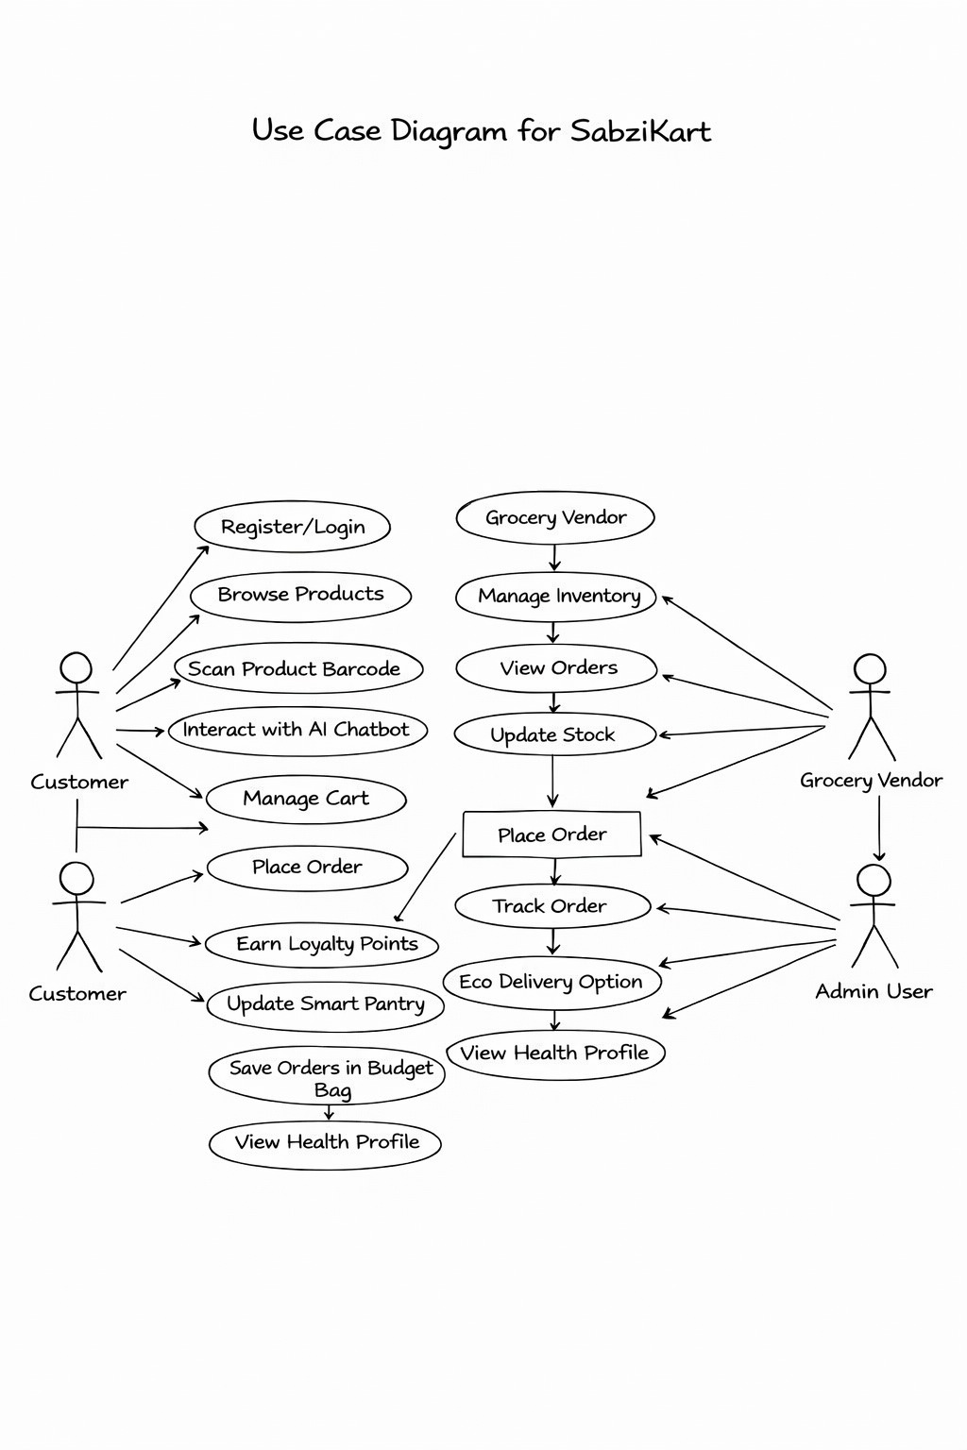

- System Architecture Diagram
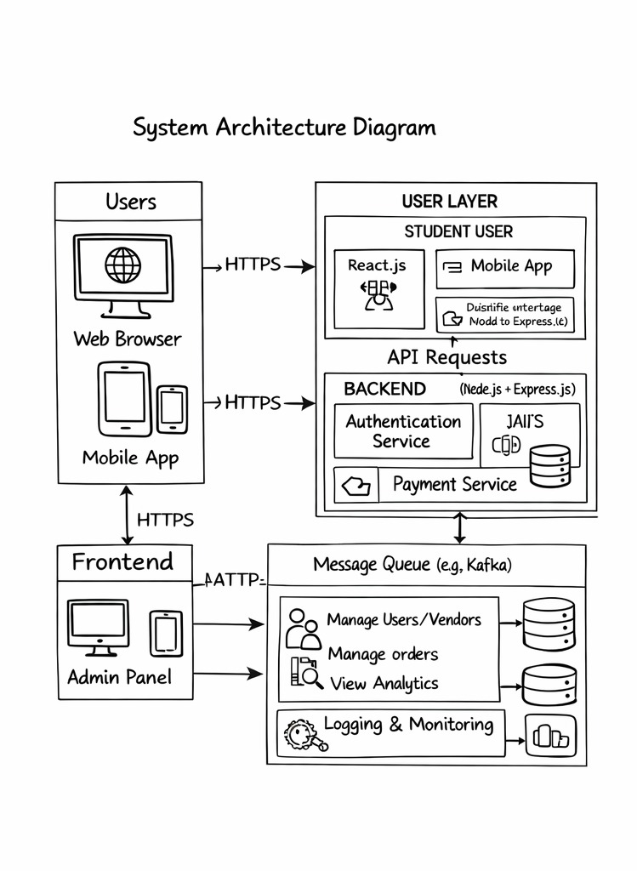
- System Flowchart Diagram
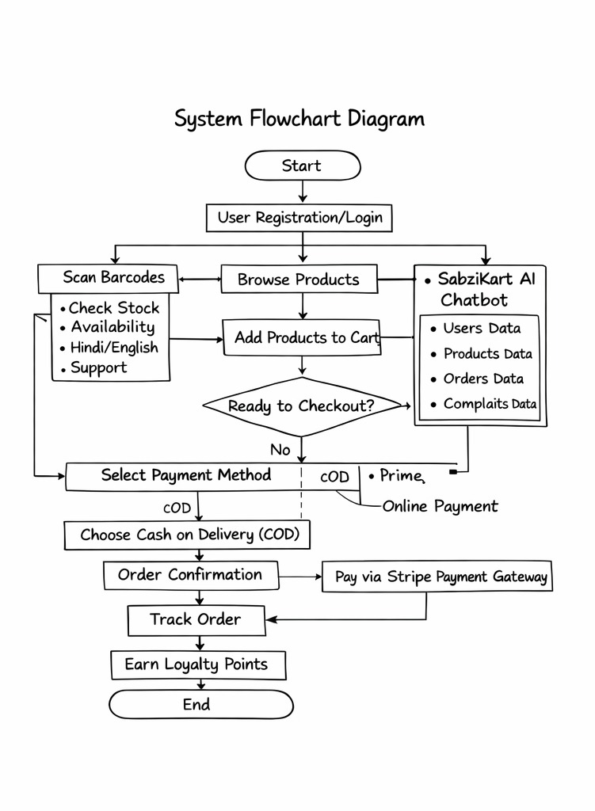
- UML Class Diagram
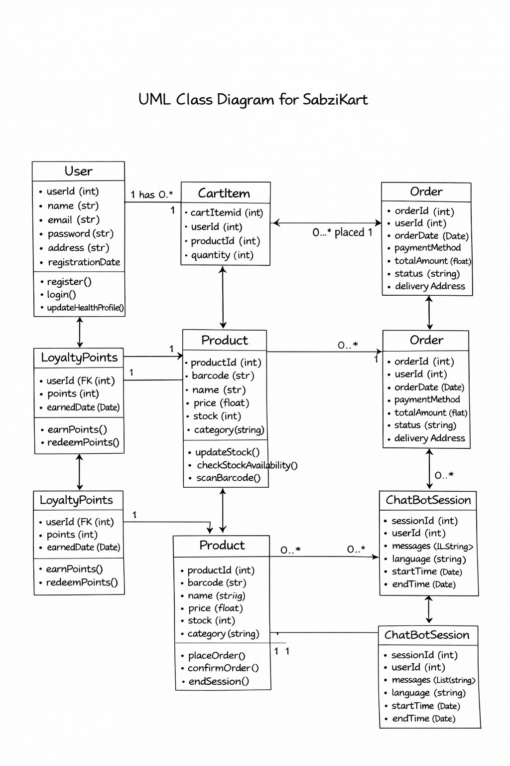
Implementation
- The AI Grocery List Scanner is a pretty cool tool that uses Google's Gemini AI to look at pictures of your grocery list. It can figure out what you've written, whether it's handwritten, printed, or even just a photo of the actual item. Then, it shows you the matching products and you can add them to your cart.
- Vendor Dashboard — Vendors can accept, reject, pack, ship, and deliver orders; real-time stats (revenue, pending, delivered) with order search and filter.
- Seller Application System — Complete flow implemented: Seller registration → Admin approval → Password setup → Dashboard login; application status trackable via application number.
- All Products Page — Category, price (low/high), and rating filters with keyword search implemented; responsive product grid layout.
- Here's how it works: we use Google OAuth2 for logging in and JWT for registering, logging in, and logging out with an email and password. We also let users upload a profile picture using Cloudinary.
- Admin Panel — Admin can manage all orders, update order status, and approve or reject seller applications with remarks.
Result
- The AI grocery list scanner is really good at figuring out what's in your photos and matching them to the right items.
- Vendor dashboard fully functional — orders managed with real-time status updates.
- The seller sign-up process is now fully operational, with registration, approval, and login features all functioning as intended.
- Product filters, search, and user authentication working smoothly and securely.

Coding:
env
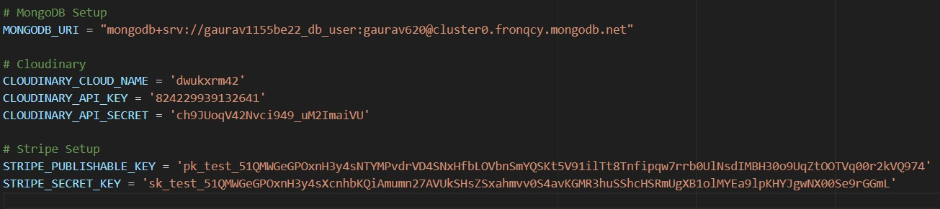

Authseller.js
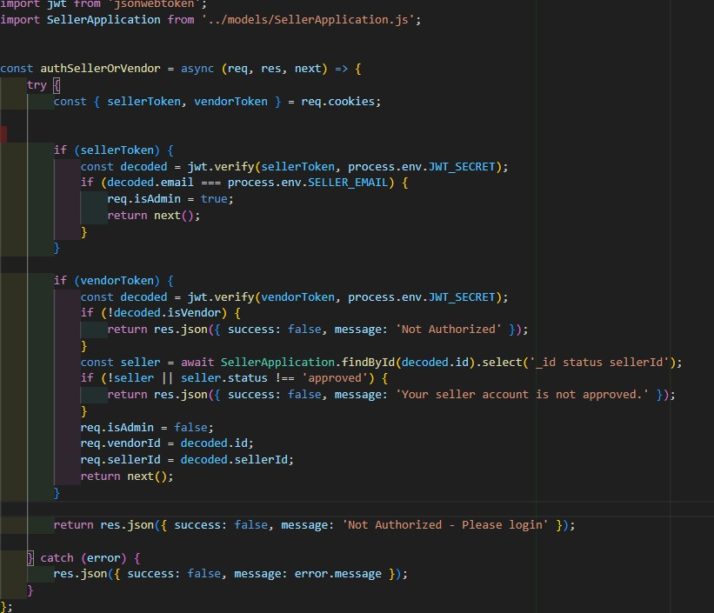

TrackOrder.jsx
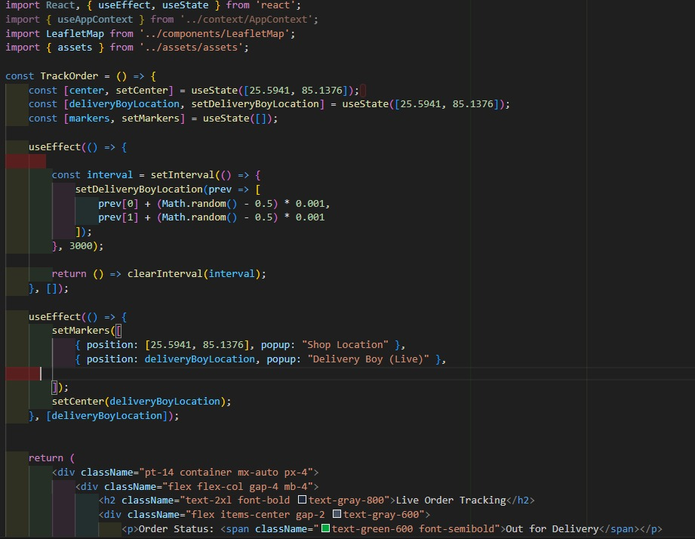

OrderController.js
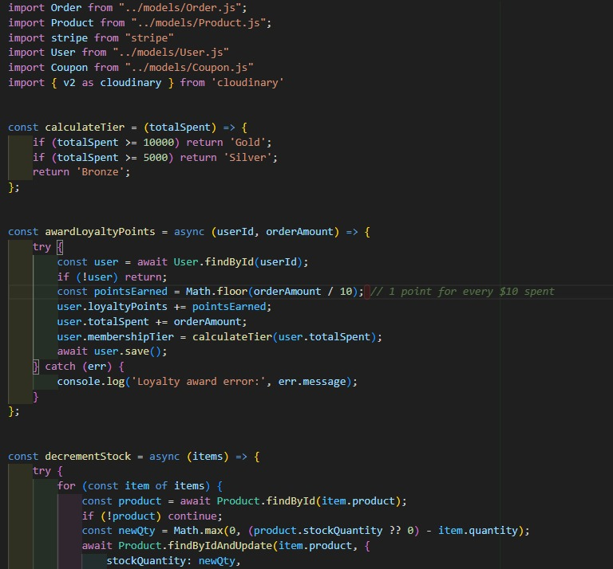

Server.js
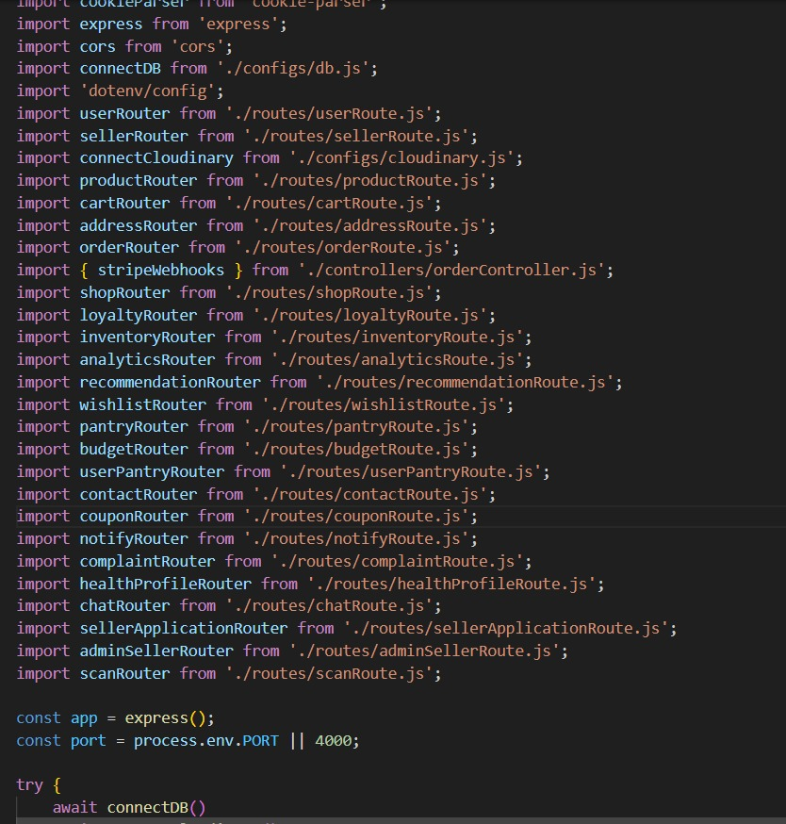

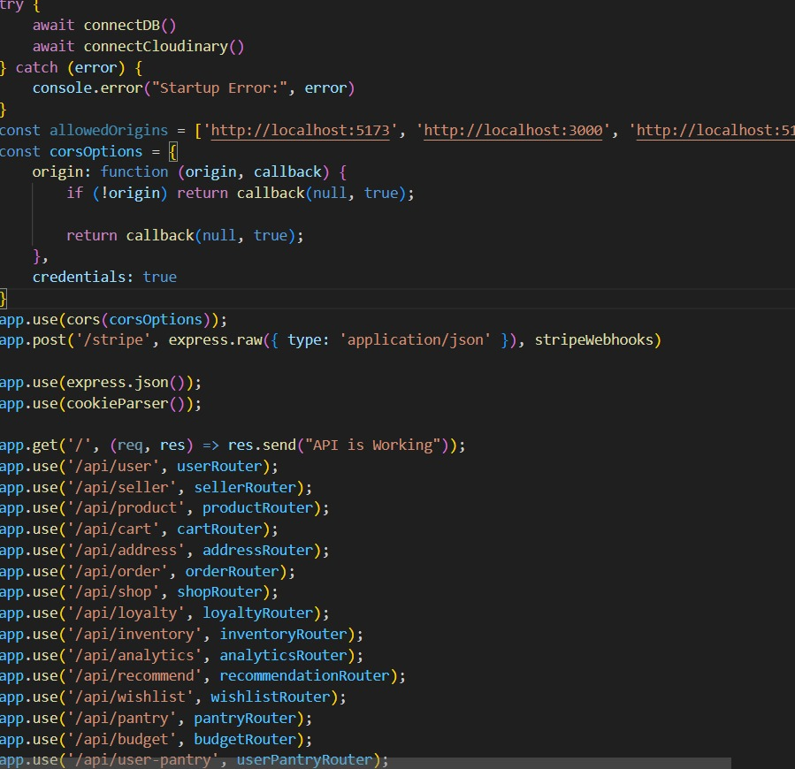

Prototype Photographs for User Side:

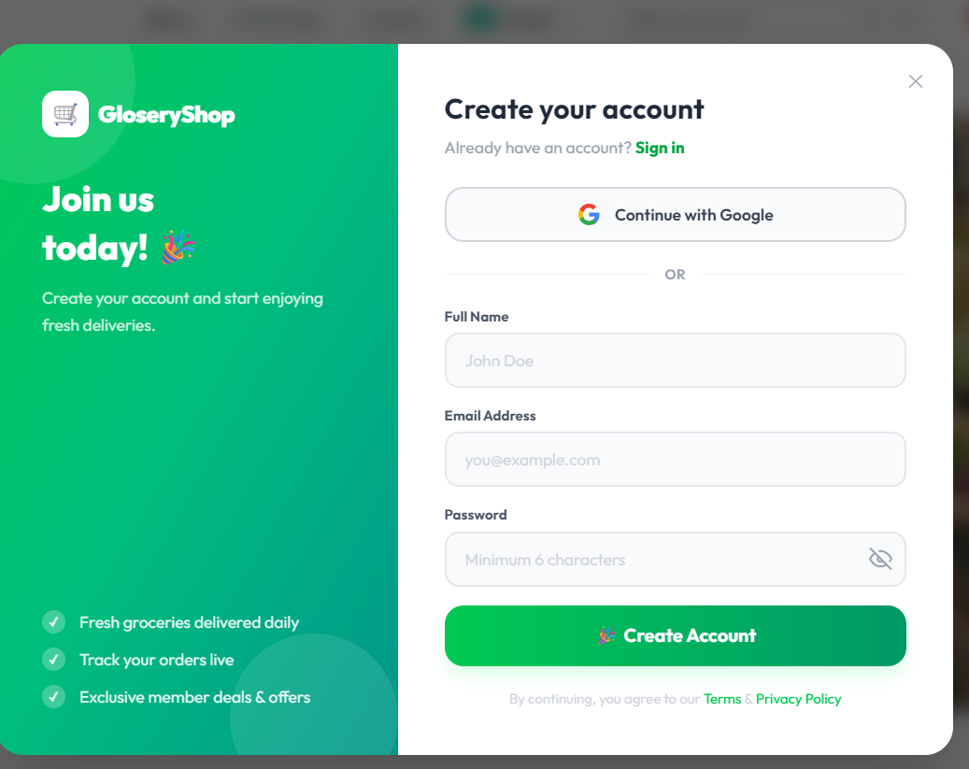
Fig: 1

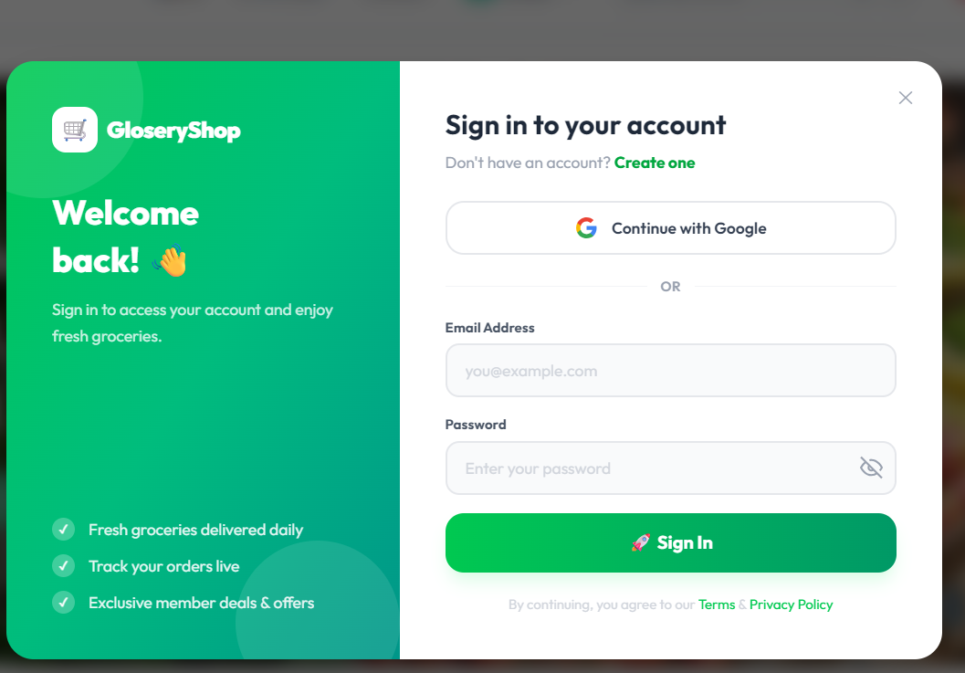
Fig: 2
Dashboard:
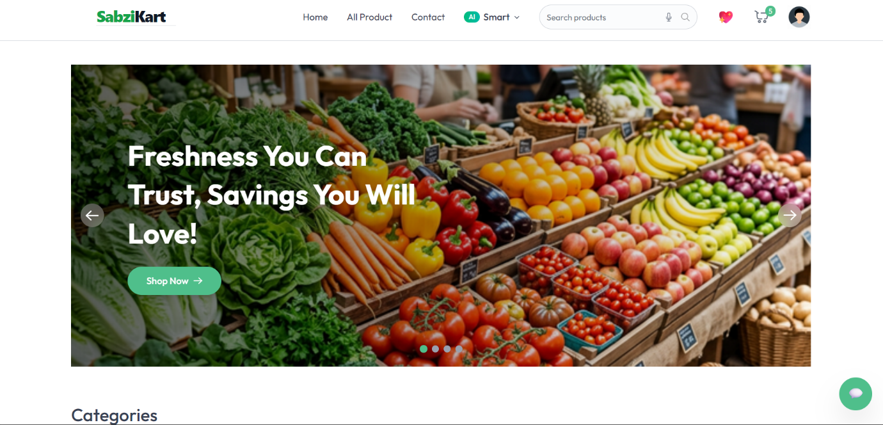
Fig: 3

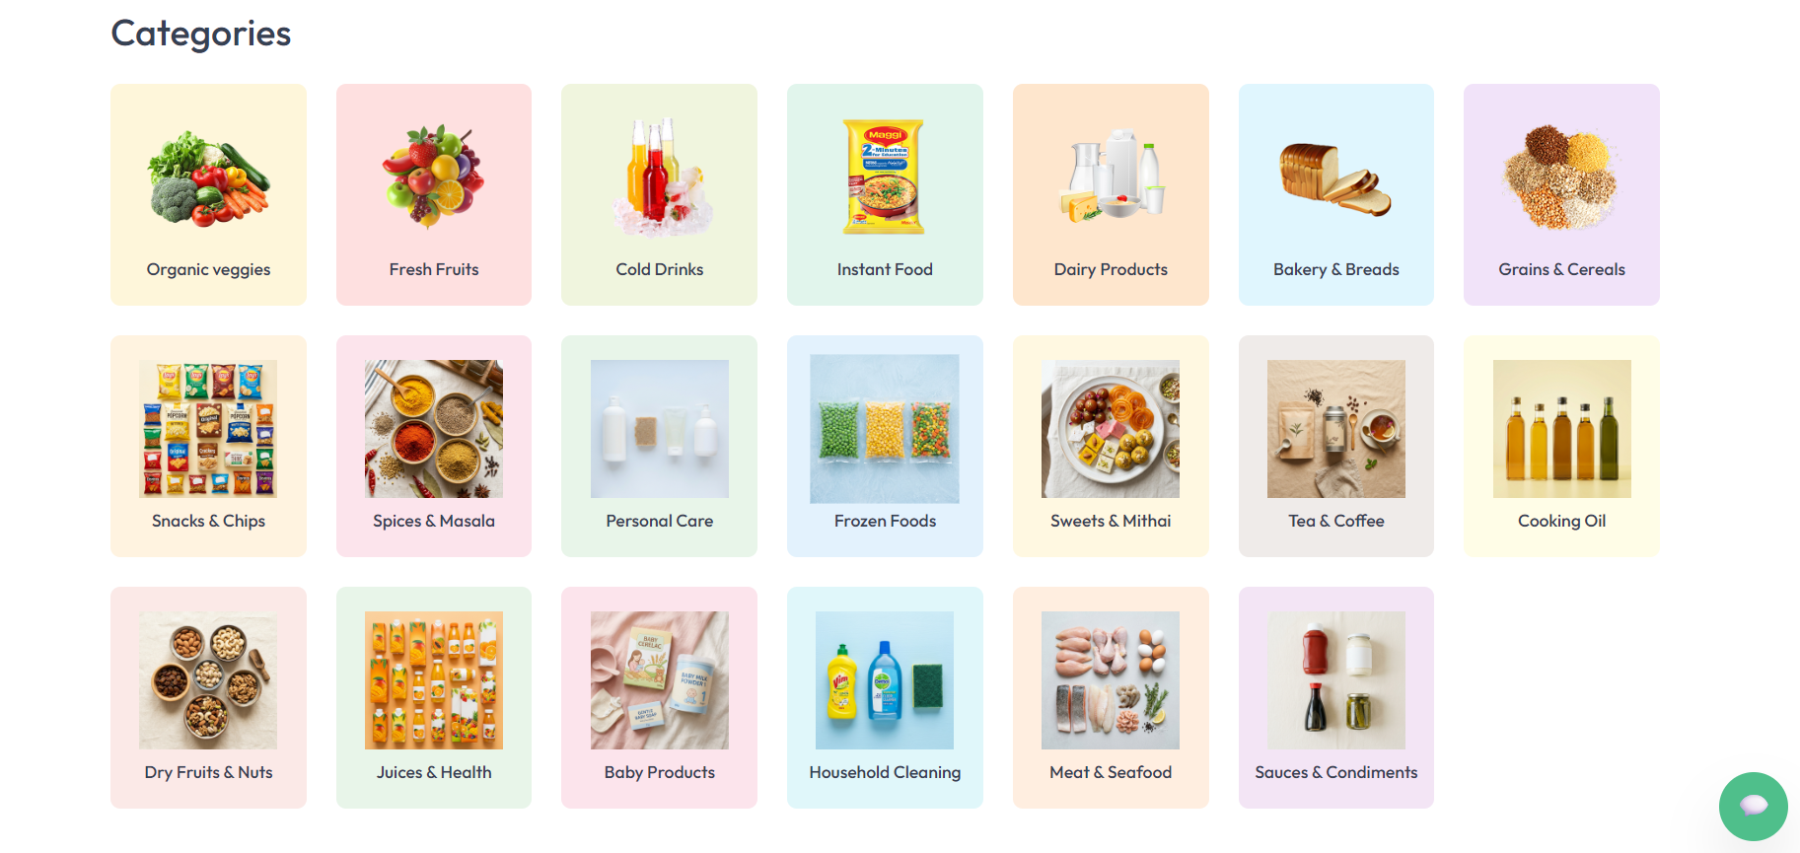
Fig: 4

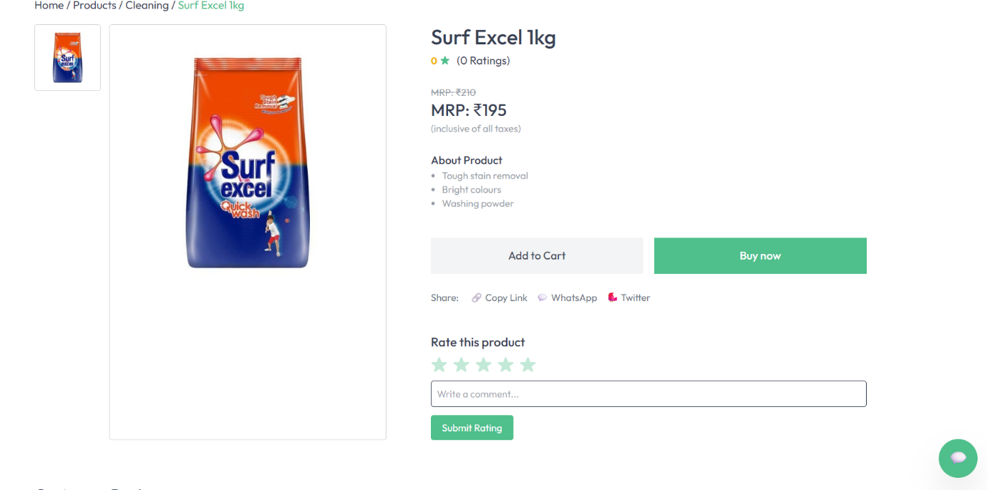
Fig: 5

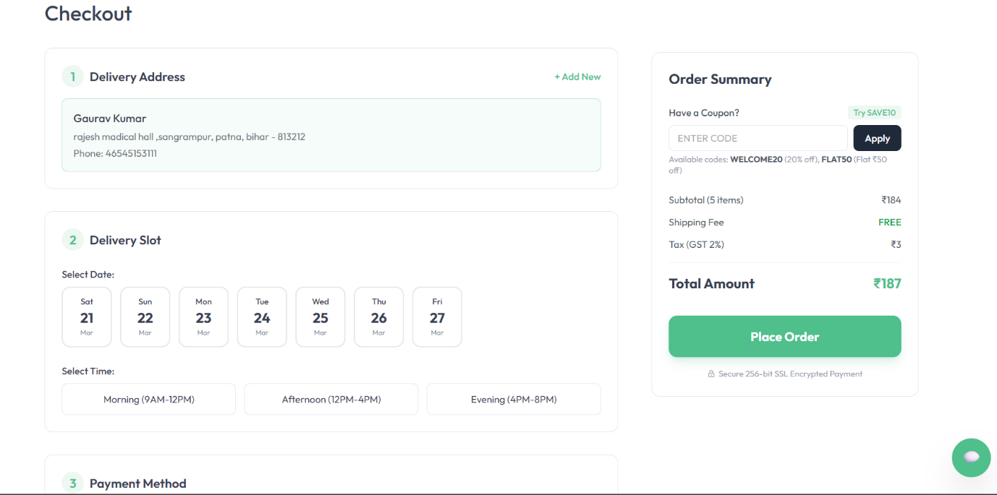
Fig: 6

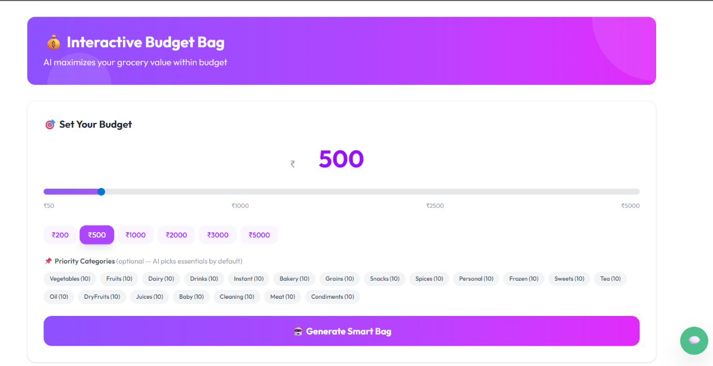
Fig: 7

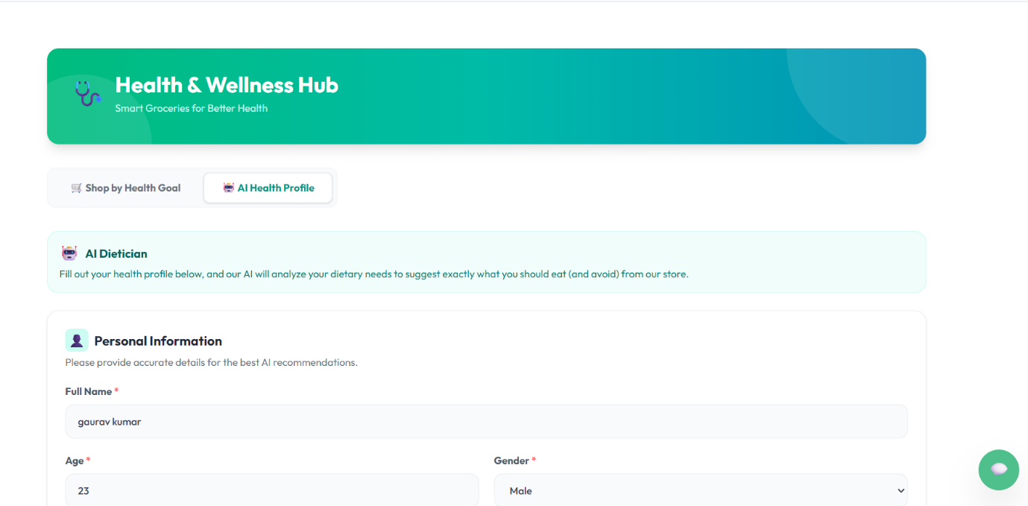
Fig: 8

Seller side
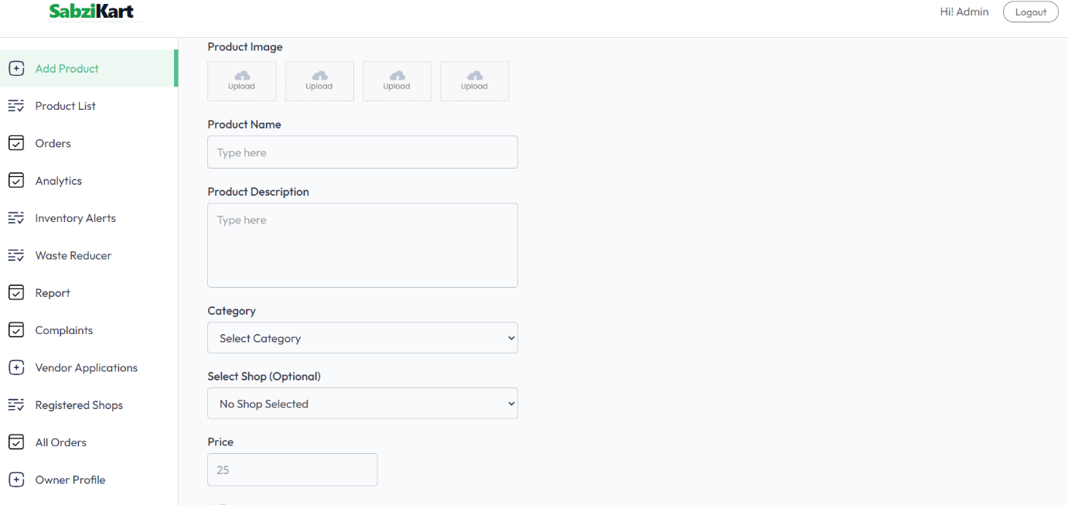
Fig: 9

Product List
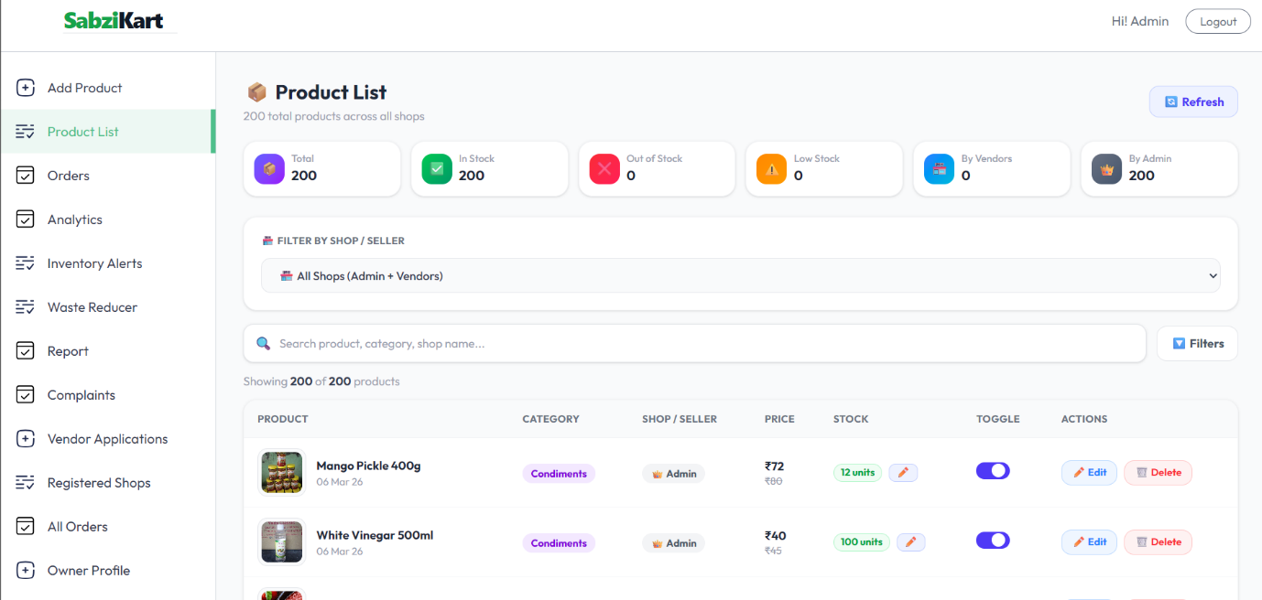
Fig: 10

Conclusion
SabziKart is a new way to shop for groceries online. It's a platform that makes buying fresh produce and daily essentials easy. The site is built using the latest technology, which means it's fast and easy to use. When you shop on SabziKart, you can see what's in stock in real-time, and you can even use a special tool to scan your groceries. The site also helps reduce waste and tracks deliveries in an eco-friendly way. Plus, you can earn rewards and loyalty points as you shop. For sellers, SabziKart makes it easy to manage their listings and keep track of sales. The platform brings local vendors and online shopping together, creating a community-driven marketplace that's good for everyone. With features like personalized shopping and smart checkout, SabziKart is changing the way we buy groceries online. It's a more sustainable and community-focused way to shop, and it's making a difference for both buyers and sellers.

